Loch Lynn Heights Fall News
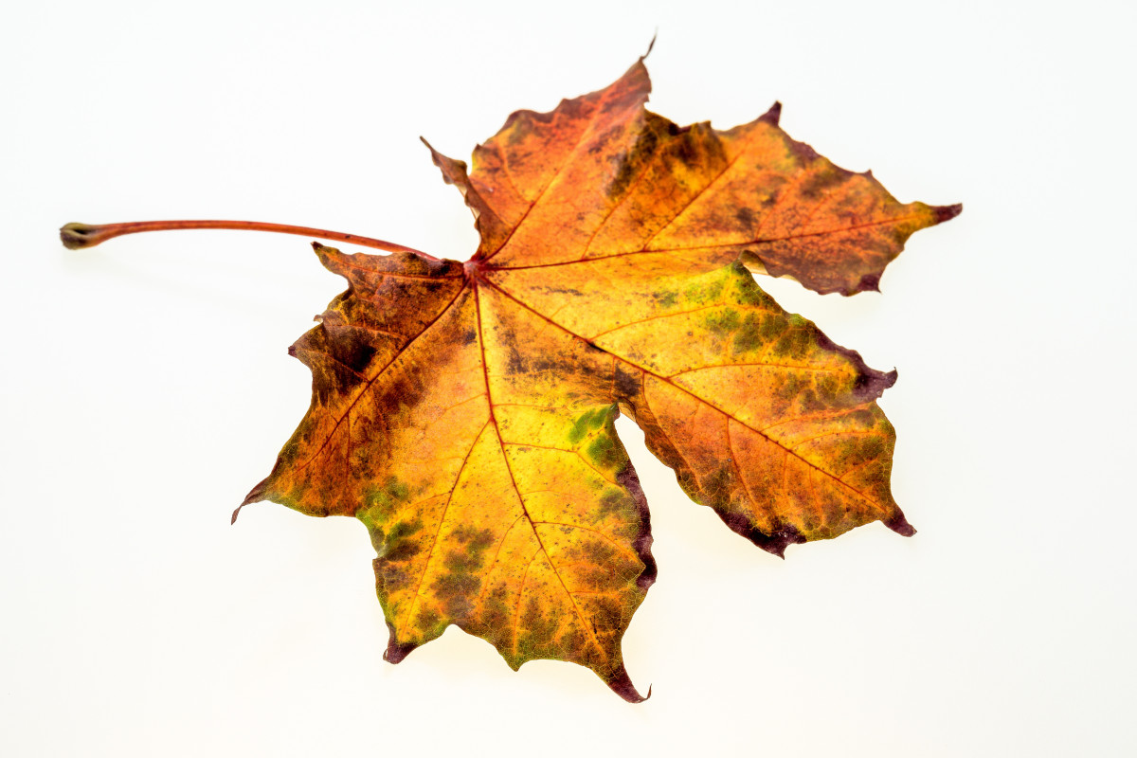
Trick or Treat – Saturday, October 31 from 5:30 to 6:30 pm. Turn on a porch light if you wish to participate.
Leaf Collection – County Roads Dept will again be collecting leaves for us. This is planned for the week of Monday, Oct. 26, and Monday Nov. 9, weather permitting. If a 3rd collection is needed, it will be mid-November. Please rake leaves to the edge of the street, and remove hard objects like sticks, rocks, etc. that damage the equipment.
Town election - will not be held this November since only Mayor Friend filed for the mayor’s office, and Barbara Rexroad, presently on Council, filed for that position. They will serve additional 2-year terms. Council will be seeking nominations for another member to be added.
Tar and chip coating – planned for some alleys and other areas must be postponed until spring, as the rainy weather has caused the County Roads Dept to fall behind on their scheduled work.

